Trinity Technology Group

cALIFORNIA dEPARTMENT OF tECHNOLOGY

agile vendor pool pROPOSAL

NATURAL DISASTER NOTIFICATION SYSTEM

User guide

Table of Contents

1 Menu 2

2 User Profile and Opt in/Opt out 4

2.1 User Profile Creation and Opt In 4

2.2 Update User Profile 5

2.3 Opt Out of Notification(s) 7

3 Incidents and Notification 9

3.1 Sending Incidents and Notification 9

# Menu

Authorized users can access different parts of the system using the global navigation menus, which are available on all pages. The menu displayed will vary depending on the role(s) assigned to each user. An individual may be granted multiple roles to provide access to a range of functionalities as described later in this User Guide.

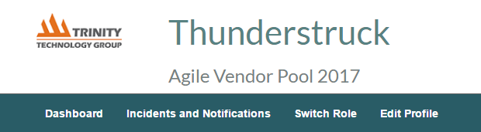

Dashboard: The system will display a dashboard based on the functionality of a user role.

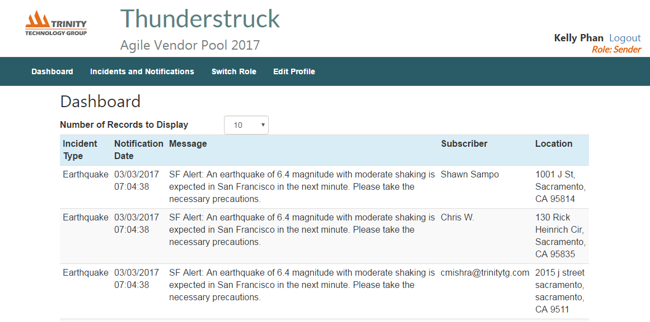

* A receiver will be able to view all of the incident notifications in their affected area. They are able to opt in and out of receiving notifications via email, SMS and push.
* A sender will have the ability to create and send notifications to end users in the affected natural disaster areas.
* A monitor will be able to view the status of notifications being sent out.
* An analyst will be able to view reports on demographics of users, quantity of notifications, and locations of affected areas.
* An administrator will be able to manage data from different agencies and view all subscriber information, notifications sent, maps of affected areas and etc.

Incidents and Notifications: Internal users with a sender role will use this menu item to send out notifications to users in the system.

Switch Role: An internal user may be granted multiple roles to provide access to a range of functionalities as described later in this User Guide.

|  |  |
| --- | --- |
| **Steps to Complete Process** | |
| 1. To switch a user role, select “Switch Role” on the global navigation menu. |  |
| 1. Change the radio button to the desired role and click on “OK” |  |

Edit Profile: System users will use this menu item to update their user profile to maintain current user information and update message delivery type.

# User Profile and Opt in/Opt out

## User Profile Creation and Opt In

The system allows an external user to create a user profile to receive notification when a natural disaster occurs. The user also has the ability to opt in for 3 different types of notifications at registration.

|  |  |  |
| --- | --- | --- |
| **Steps to Complete Process** | | |
| 1. Click on the “Register” link. | |  |
| 1. Enter a username, user display name, password, confirm password and click on register. | |  |
| 1. Enter street address, city, state, zip code, email address, phone number and click on save. |  | |
| 1. Select the checkbox to opt in for email, push and/or SMS notification and click on save. |  | |

## Update User Profile

The system allows an external user to update their user profile for the purpose of maintaining user information and update message delivery type.

|  |  |
| --- | --- |
| **Steps to Complete Process** | |
| 1. Enter a username and password and click on “login” |  |
| 1. Update desired fields and notification delivery method and click on save. |  |
| 1. To change password, enter in a new password in change password, confirm password and click on “Change Password” |  |

## Opt Out of Notification(s)

The system allows an external user to opt out when they are no longer interested in receiving notifications.

|  |  |
| --- | --- |
| **Steps to Complete Process** | |
| 1. Enter a username and password and click on “login” |  |
| 1. Un-check the checkbox of the notification delivery method and click on save. |  |

# Incidents and Notification

## Sending Incidents and Notification

|  |  |
| --- | --- |
| **Steps to Complete Process** | |
| 1. Enter a username and password and click on “login” |  |
| 1. Click on “Incidents and Notifications” |  |
| 1. Click on the icon on the top right of the map to view different types of incidents on the map. |  |
| 1. Select the type of notification to send in step 2. Select the radius of the affected area to notify in step 3. |  |
| 1. Click on a point on the map to highlight the notification area. A notification message box will appear. |  |
| 1. Enter a message and click notify to send. |  |